**A Project Report**

**On**

**Pandemic and Stress**

FOR AISSCE 2022 EXAMINATION

[AS A PART OF INFORMATICS PRACTICES COURSE]

**SUBMITTED BY-**

NAME: Ananya

ROLL NO: 14646145

**[UNDER THE GUIDANCE OF**

**MS. P.DEEPTI (HOD)]**

**CERTIFICATE**

This is to certify that ANANYAof class XII-D (Humanities) has successfully completed the project work under guidance of Ms. P.Deepti. She has done her work all in original and finished it in due course of time as per CBSE guidelines.

**NAME: Ananya**

**Class: XII**

**Section: D (Humanities)**

**HOD Principal**

**MS. P.Deepti MS. Monika Mehan**

**ACKNOWLEDGEMENT**

I undertook this project work, as the part of my XII IP course. I had tried to apply my best knowledge and experience, gained during and class work experience. However, developing software is generally a quite complex and time-consuming process. It requires a systematic study, insight vision and professional approach during the design and development. Moreover, the developer always feels the need, the help and good wishes of the people near you, who have considerable experience and idea.

I would like to extend my sincere thanks and gratitude to my teacher **MS. P. Deepti**, for giving valuable time and moral support to develop this software.

I also feel indebted to my friends and teammates, Diya Negi and Shreshtha Naugai for the valuable hard work and suggestions during the project work.

**CONTENT**

|  |  |  |
| --- | --- | --- |
| **S.No.** | **Topics** | **Page No.** |
| 1. | Introduction | 5-6 |
| 2. | Objective and Scope | 7 |
| 3. | System Requirement | 8 |
| 4. | Python  Installing Python | 9-10 |
| 5. | .csv File  Importing .csv File | 11-13 |
| 6. | .csv Project File | 14-15 |
| 7. | Program Code | 16-22 |
| 8. | Output   * Bar Graph- Gender Analysis * Line Graph- Age Group Analysis * Histogram- Overall Age Distribution Analysis | 23- 30 |
| 9. | Mean, Median and Mode | 31 |
| 10. | Mean, Median and Mode Output | 32-36 |
| 11. | Bibliography | 37 |

INTRODUCTION

The COVID-19 pandemic has taken hold of us, physically and mentally. It has dragged us to the darkest niche of our minds. Moreover, the fear of encountering the virus has made us anxious and exhausted.

After the pandemic, stress levels have surged. For the purpose of our study and the Project, we have opted to use these criteria.

Tables and graphs can be used to organise and evaluate the collected data.

With the help of Python, we've created a module that calculates and analyses two primary data sets: first, stress-related symptoms' fluctuation in different age groups (15-18, 19-30, 30-45 years old), then stress-related symptoms' fluctuation in female and male participants.

A huge country's data will now be easier to handle, and stress-related disorders will now be easily identifiable.

As a result of this, residents would be made aware of the significance of mental health, especially in these trying times.

This project, which incorporates data collection, has been built from the ground up.

For graphical assessment and analysis, our project has all the necessary data. In addition, it calculates the mean, median, and mode.

It's important to remember that no project is final, and this Project is no exception. It can be launched even at an international level by increasing the diversity of data in our project.

OBJECTIVE AND SCOPE OF THE PROJECT

After the pandemic, stress levels have surged. For the purpose of our study and the Project, we have opted to use this criterion.

A huge country's data will now be easier to handle, and stress-related illnesses will be more easily identified.

As a result of this, residents would be made aware of the significance of mental health, especially in these trying times. This project, which incorporates data collection, has been built from the ground up.

For graphical assessment and analysis, our project has all the necessary data. In addition, it calculates the mean, median, and mode.

It's important to remember that no project is final, and this Project is no exception. It can be launched even at an international level by increasing the diversity of data in our project.

SYSTEM REQUIREMENT

**Python Minimum Hardware Requirements**

* Modern Operating **System**:
* x86 64-bit CPU (Intel / AMD architecture)
* 4 GB RAM.
* 5 GB free disk space



PYTHON

Python is a high-level, general-purpose programming language that can be executed by an interpreter. In 1991, Guido van Rossum created Python, a programming language with a design philosophy that promotes code readability by making extensive use of whitespace.

INSTALLING PYTHON

1. Download Python <https://www.python.org/>

1. Install it

.CSV FILE

A comma-separated values file is a delimited text file that uses a comma to separate values. Each line of the file is a data record. Each record consists of one or more fields, separated by commas. The use of the comma as a field separator is the source of the name for this file format.

IMPORTING .CSV FILE

A CSV file can be prepared in any excel sheet.

This file can be given a name and then can be saved in the system.

Any such database file can be imported in Python Pandas.

Thus, enabling the database task easy and importing data, thus compiling data

This will reduce our re-preparation of data in Python Pandas.

Also, it helps in reducing workload and complexity of programming.

The csv file thus imported can be used for performing various tasks as per the necessity of the programmer and instructions of the customer.

The steps involved in importing csv files are as follows:

import pandas as pd

df = pd.read_csv(r'Path where the CSV file is stored\File name.csv')

print(df)

**Step 1: Capture the File Path**

Firstly, capture the full path where your CSV file is stored. In my case, the CSV file is stored under the following path: ***C:\Users\admin\Desktop\ananya\IP project survey.csv***

You’ll need to modify the Python code below to reflect the path where the CSV file is stored on *your* computer. Don’t forget to include the:

* File name (as highlighted in green). You may choose a different file name, but make sure that the file name specified in the code matches with the actual file name
* File extension (as highlighted in blue). The file extension should always be ‘.csv’ when importing CSV files

**Step 2: Apply the Python code**

Type/copy the following code into Python, while making the necessary changes to your path. Here is the code for our example (you can find additional comments within the code itself):

import pandas as pd

df=pd.read_csv(r'C:\Users\admin\Desktop\ananya\IP project survey.csv')

print(df)

#to read the csv file (put 'r' before the path string to address any special characters in the path, such as '\').

#don’t forget to put the file name at the end of the path + ".csv"

### Step 3: Run the Code

### Finally, run the Python code and you’ll get the output in Python

.CSV PROJECT FILE

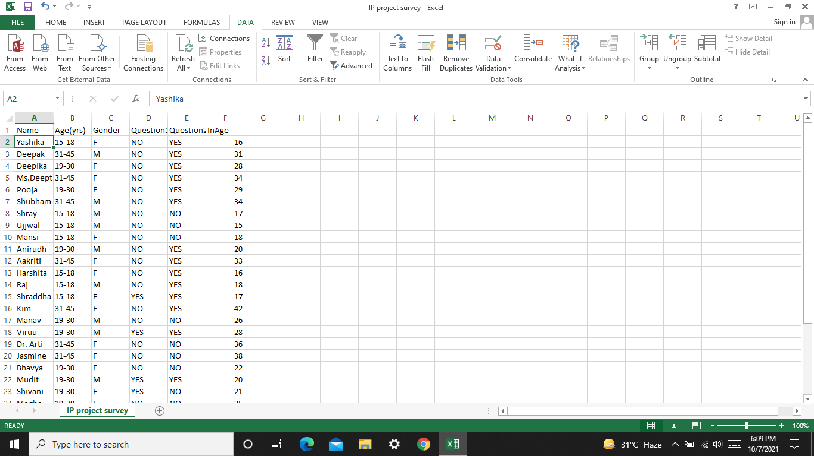

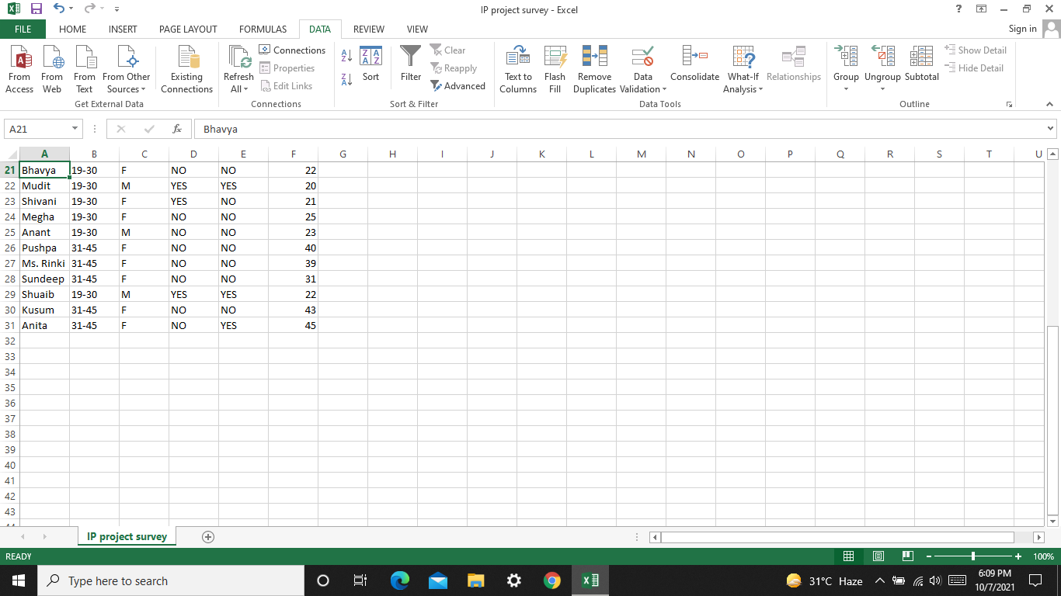

PROGRAM CODE

import pandas as pd

import matplotlib.pyplot as plt

import numpy as np

data=pd.read_csv(r'C:\Users\admin\Desktop\ananya\IP project survey.csv', sep=',', header=0, names=['Name','Age(yrs)', 'Gender', 'Question 1', 'Question 2','InAge'])

df=pd.DataFrame(data,columns=['Name','Age(yrs)', 'Gender', 'Question 1', 'Question 2','InAge'])

x=int(input("Enter 1 for bar graph for Gender Analysis or 2 for line plot for Age Group Analysis or 3 for histogram for Overall Age Distribution Analysis: "))

if x==1:

import matplotlib.pyplot as plt

c=['total','increased','decreased','constant']

a=[19,8,1,10]

b=[11,4,0,7]

plt.barh(c,a,color='aqua', label='Females')

plt.barh(c,b,color='deeppink', label='Males')

plt.xticks(np.arange(1,25,1))

plt.title('Gender Analysis')

plt.ylabel('Status')

plt.xlabel('Number of Females/Males')

plt.legend()

plt.show()

elif x==2:

y=str(input('Enter \'a\' for Age Group 15-18, \'b\' for Age Group 19-30 or \'c\' for Age Group 31-45: '))

if y=='a':

x=[1,9]

y=[8,2]

z=['Yes','No']

plt.plot(z,x,color='teal',linewidth=5,label='Before Pandemic')

plt.plot(z,y,color='darkviolet',linewidth=5,label='After Pandemic\'s Start')

plt.grid(True)

plt.ylabel('Frequency')

plt.xlabel('Yes/No Anwer')

plt.title('Age Group Analysis (15-18)')

plt.legend()

plt.show()

elif y=='b':

x=[4,6]

y=[5,5]

z=['Yes','No']

plt.plot(z,x,color='gold',linewidth=5,label='Before Pandemic')

plt.plot(z,y,color='darkred',linewidth=5,label='After Pandemic\'s Start')

plt.title('Age Group Analysis (19-30)')

plt.grid(True)

plt.ylabel('Frequency')

plt.xlabel('Yes/No Anwer')

plt.legend()

plt.show()

elif y=='c':

x=[0,10]

y=[4,6]

z=['Yes','No']

plt.plot(z,x,linewidth=5,color='mediumvioletred',label='Before Pandemic')

plt.plot(z,y,linewidth=5,color='darkgreen',label='After Pandemic\'s Start')

plt.grid(True)

plt.ylabel('Frequency')

plt.xlabel('Yes/No Anwer')

plt.title('Age Group Analysis (31-45)')

plt.legend()

plt.show()

else:

print('Kindly enter a valid option.')

elif x==3:

x=[14,15,16,17,18,19,20,21,22,23,24,25,26,27,28,29,30,31,32,33,34,35,36,37,38,39,40,41,42,43,44,45,46]

z=[16,31,28,34,29,34,17,15,18,20,33,16,18,17,42,26,28,36,38,22,20,21,25,23,40,39,31,22,43,45]

plt.hist(z,bins=x,edgecolor='k',color='lightblue',linewidth=3,hatch='..')

plt.xticks(x)

plt.yticks([0,1,2,3])

plt.title('Age Distribution Analysis')

plt.grid(False)

plt.xlabel('Age (in Years)')

plt.ylabel('Frequency')

plt.show()

else:

print('Kindly enter a valid number.')

z=str(input('Enter \'mean\' for Mean of Age (in Years), \'median\' for Median of Age (in Years) or \'mode\' for Mode : '))

if z=='mean':

print(df.mean(numeric_only=True))

elif z=='median':

print(df.median(numeric_only=True))

elif z=='mode':

a=int(input('Enter 1 for Mode of Age (in Years) Distribution, 2 for Mode of Age Group (in Years), 3 for Mode of Gender, 4 for Mode of Answers of Stress Pre- Pandemic or 5 for Mode of Answers of Stress Post-Pandemic: '))

if a==1:

print(df['InAge'].mode())

elif a==2:

print(df['Age(yrs)'].mode())

elif a==3:

print(df['Gender'].mode())

elif a==4:

print(df['Question 1'].mode())

elif a==5:

print(df['Question 2'].mode())

else:

print('Kindly enter a valid option.')

else:

print('Kindly enter a valid option.')

**OUTPUT**

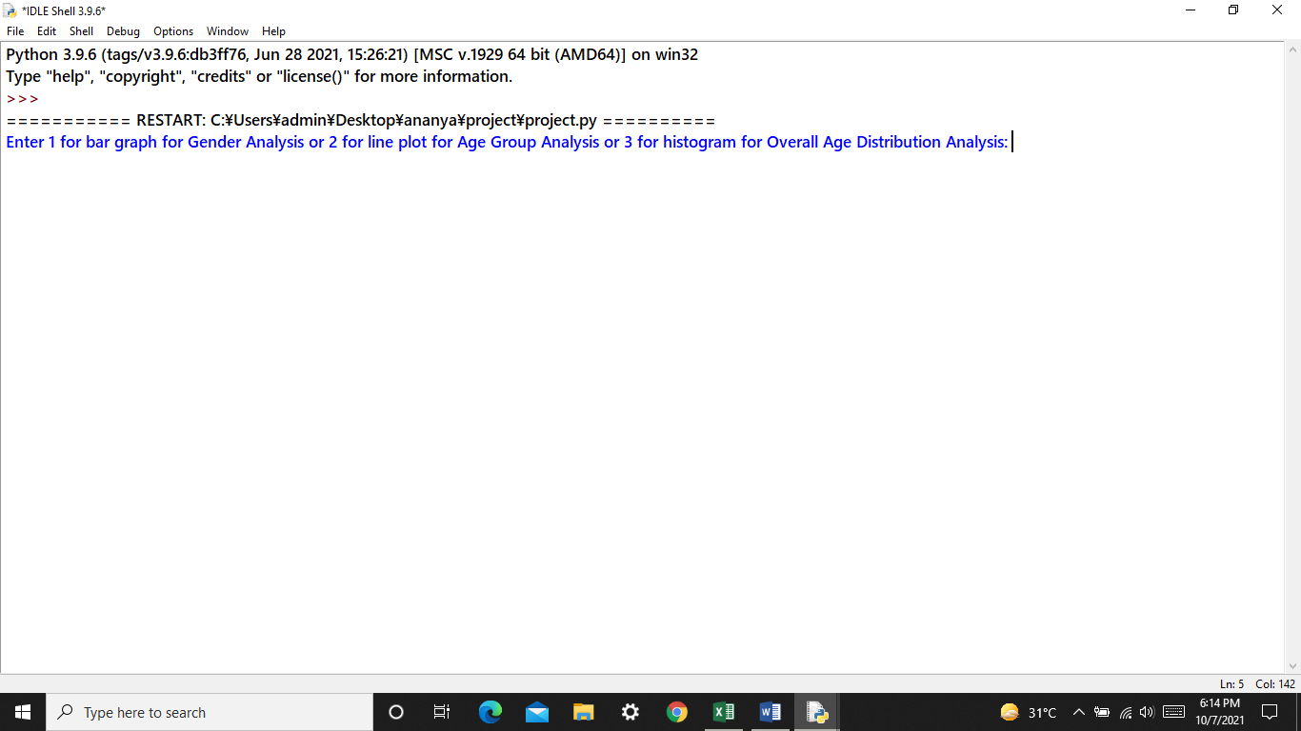

1. **Bar Graph**

**Gender Analysis**

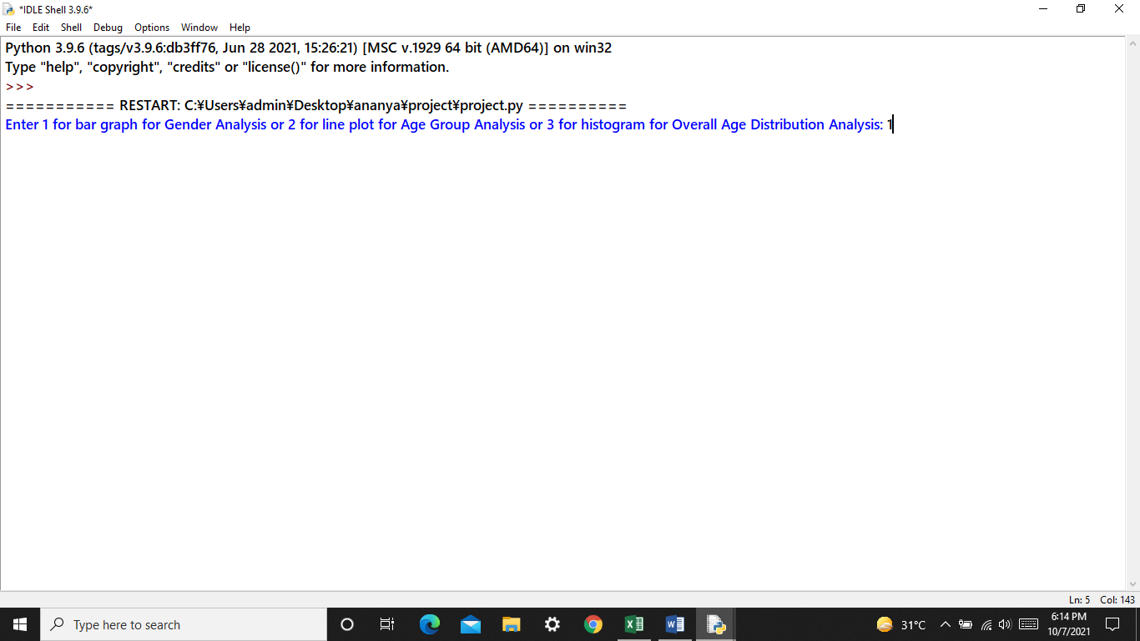

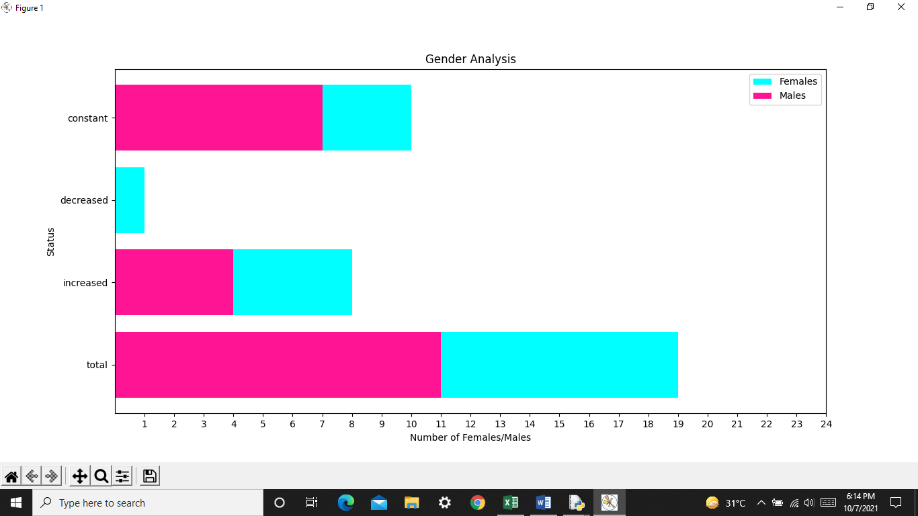

1. **Line Graph**

**Age Group Analysis**

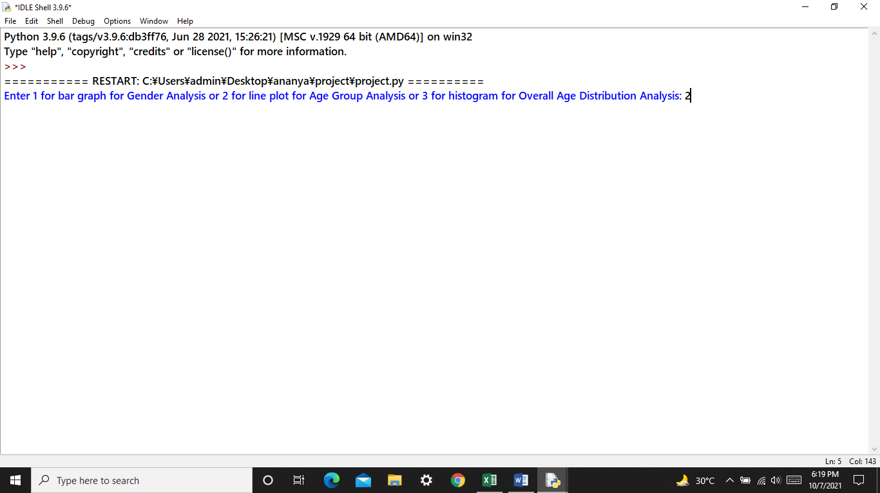

1. **Age Group 15-18**

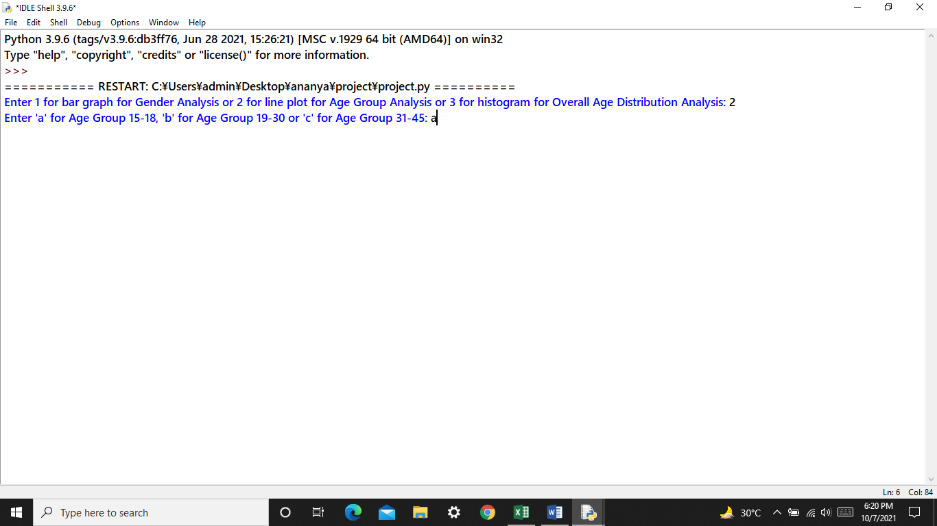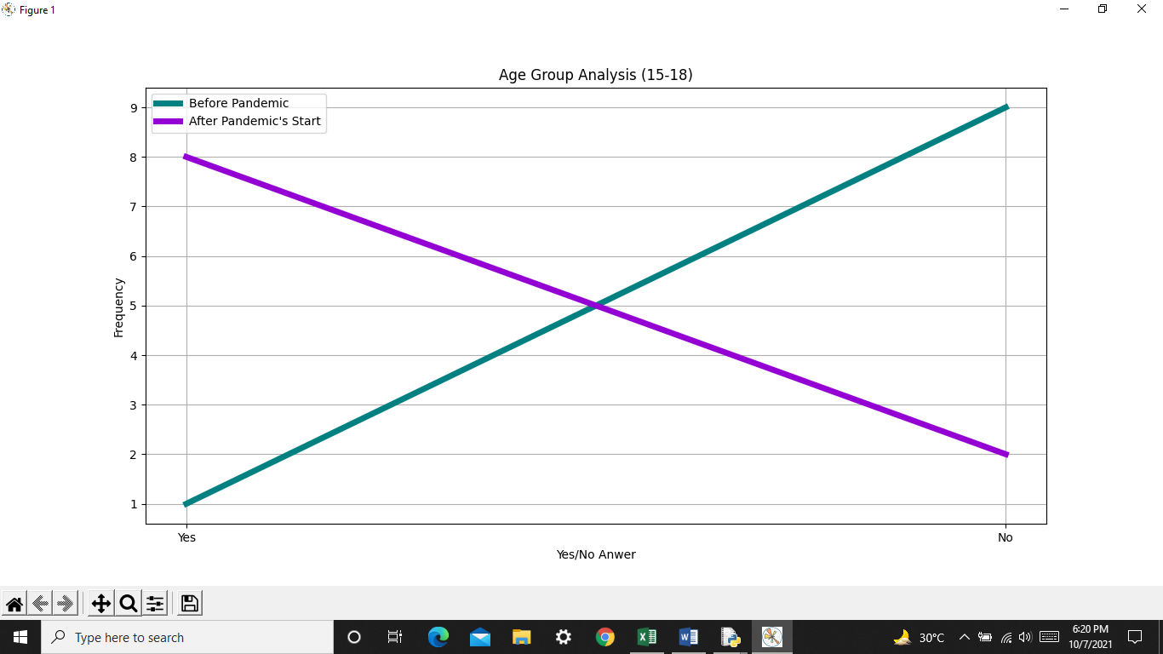

1. **Age Group 19-30**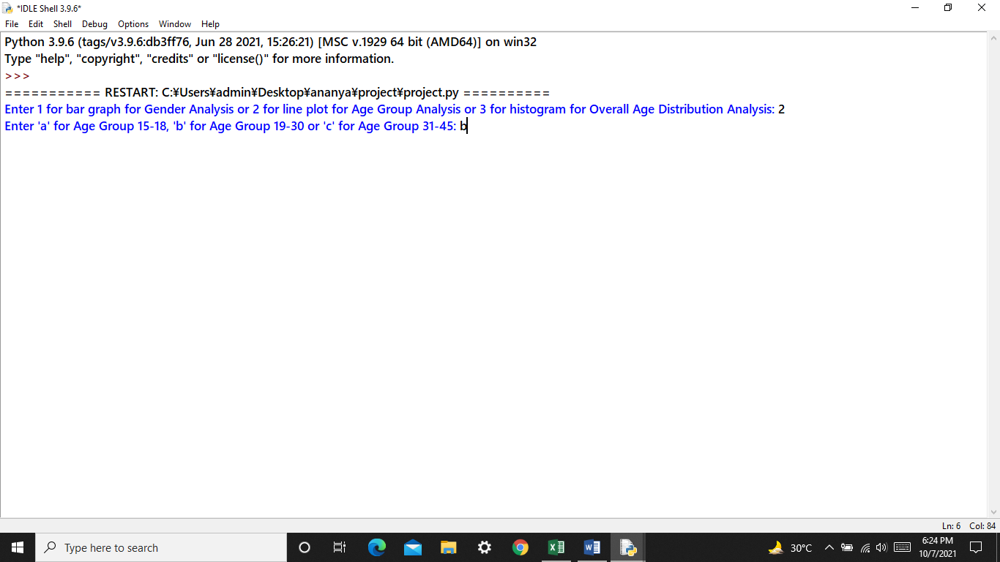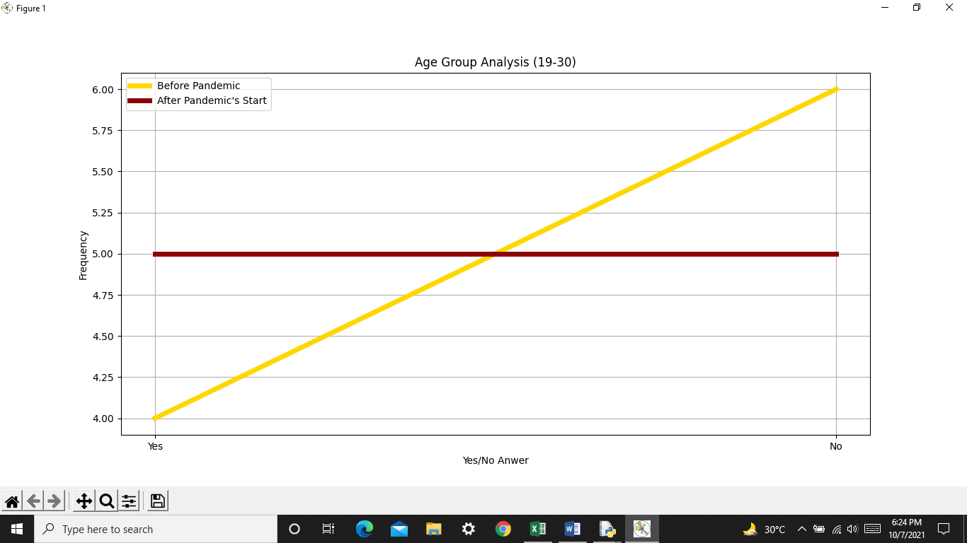
2. **Age Group 31-45**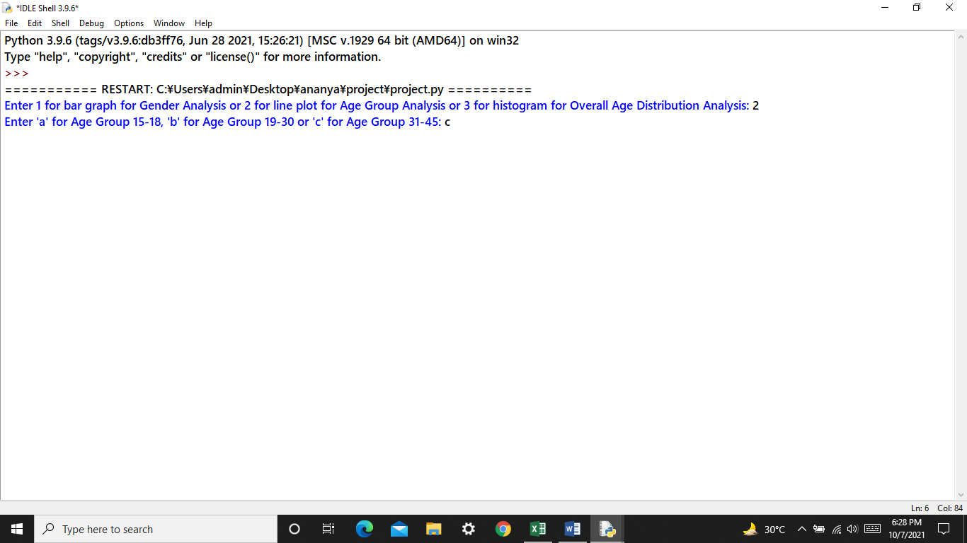

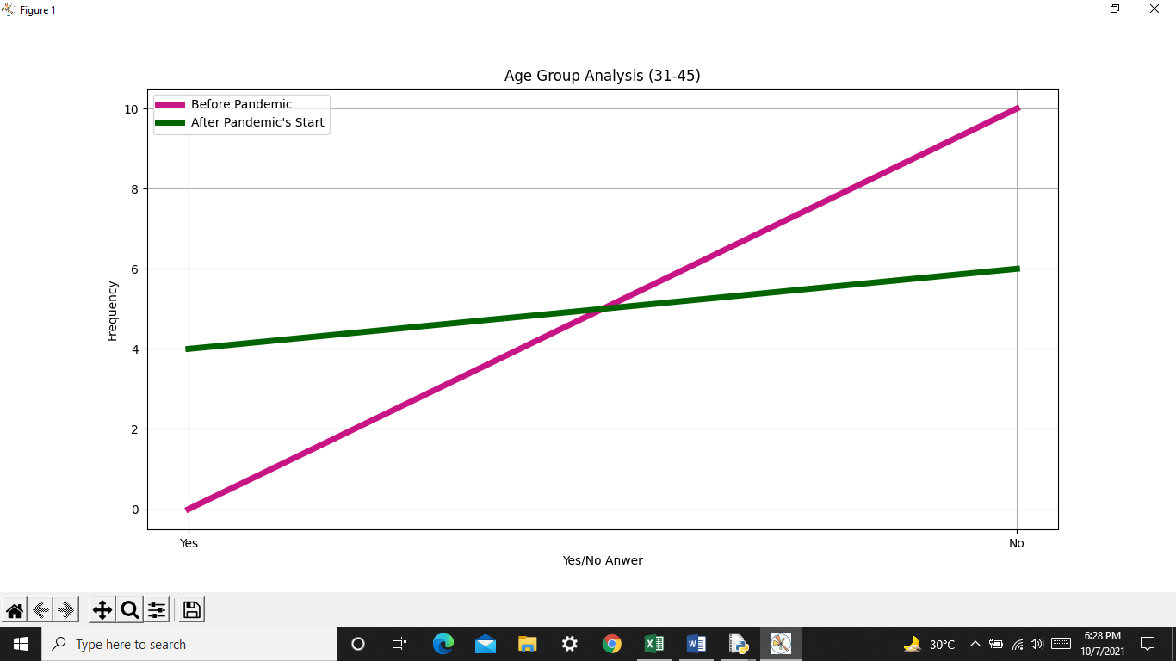

1. **Histogram**

**Overall Age Distribution Analysis**

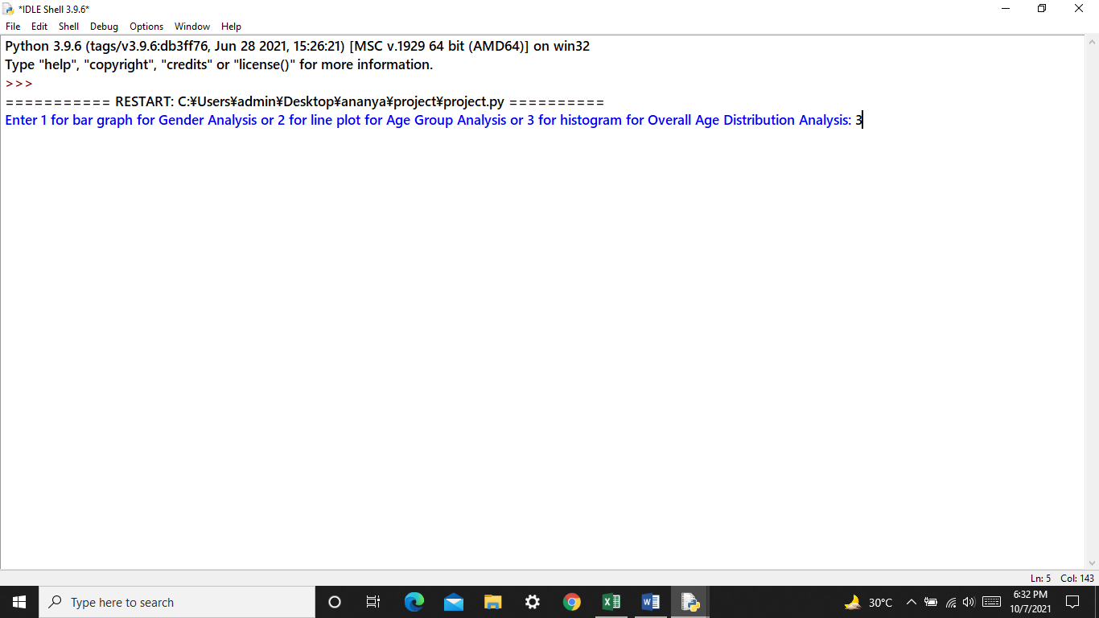

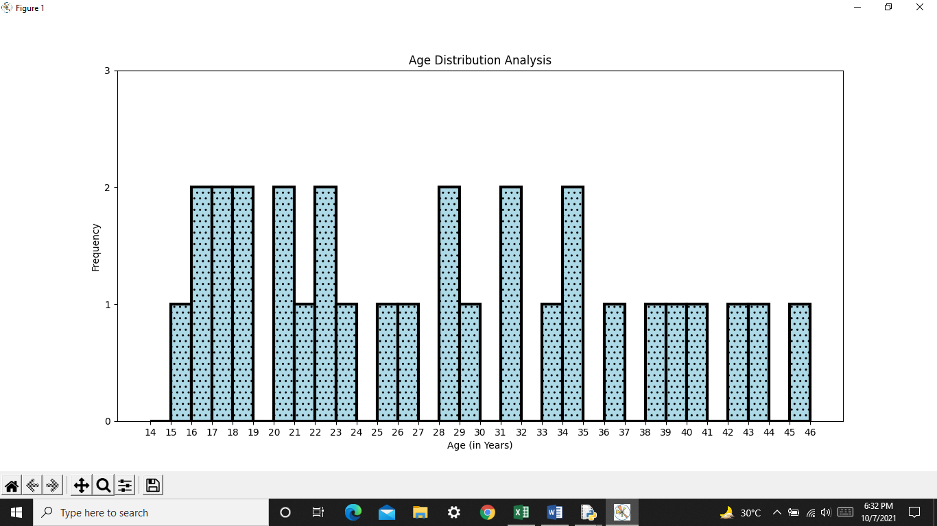

**Mean, Median, Mode**

1. **Mean** is a central value of a finite set of numbers: specifically, the sum of the values divided by the number of values.
2. **Median** is the value separating the higher half from the lower half of a data set. It can also be called the middle value of the data set.
3. **Mode** is the value that appears most often in a set of data values.

**Mean, Median, Mode**

**Output**

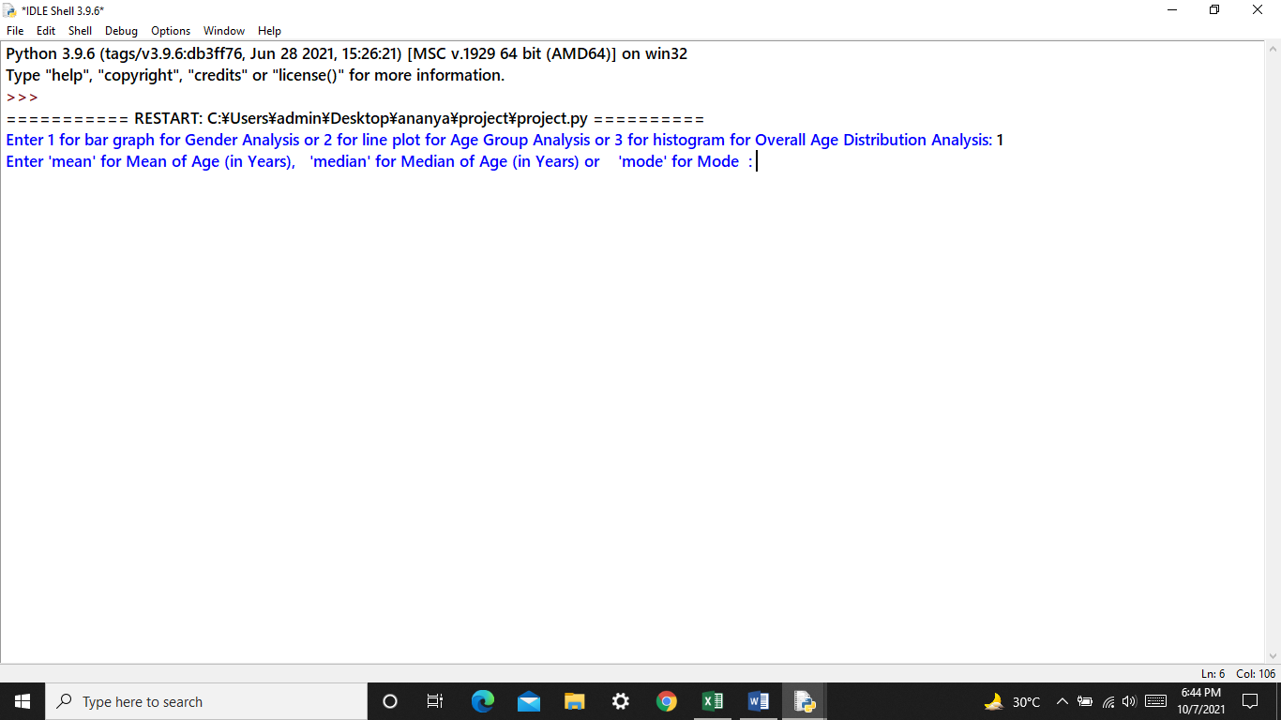

1. **Mean of Age(in Years)**

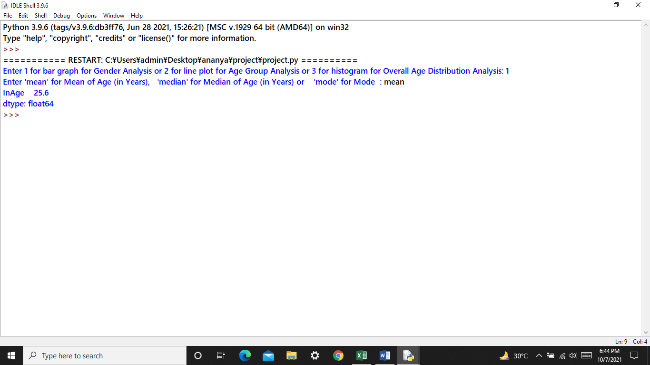

1. **Median of Age(in Years)**

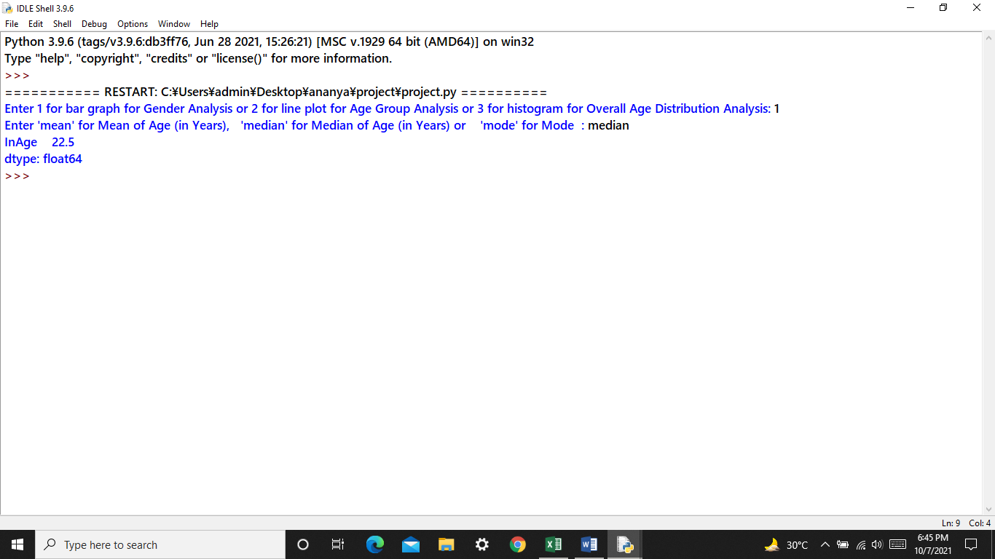

1. **Mode** 
   1. **Age (in Years) Distribution**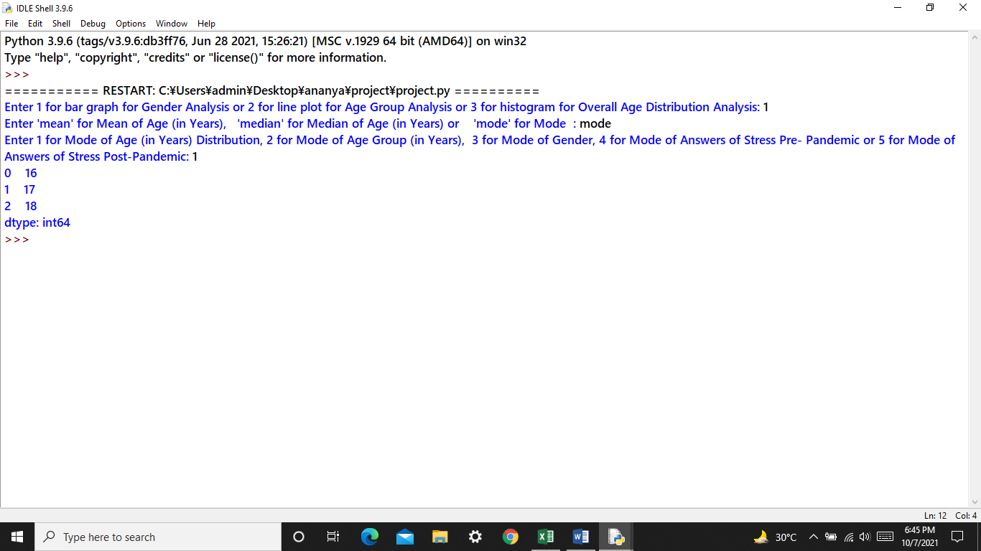
   2. **Age Group (in Years)**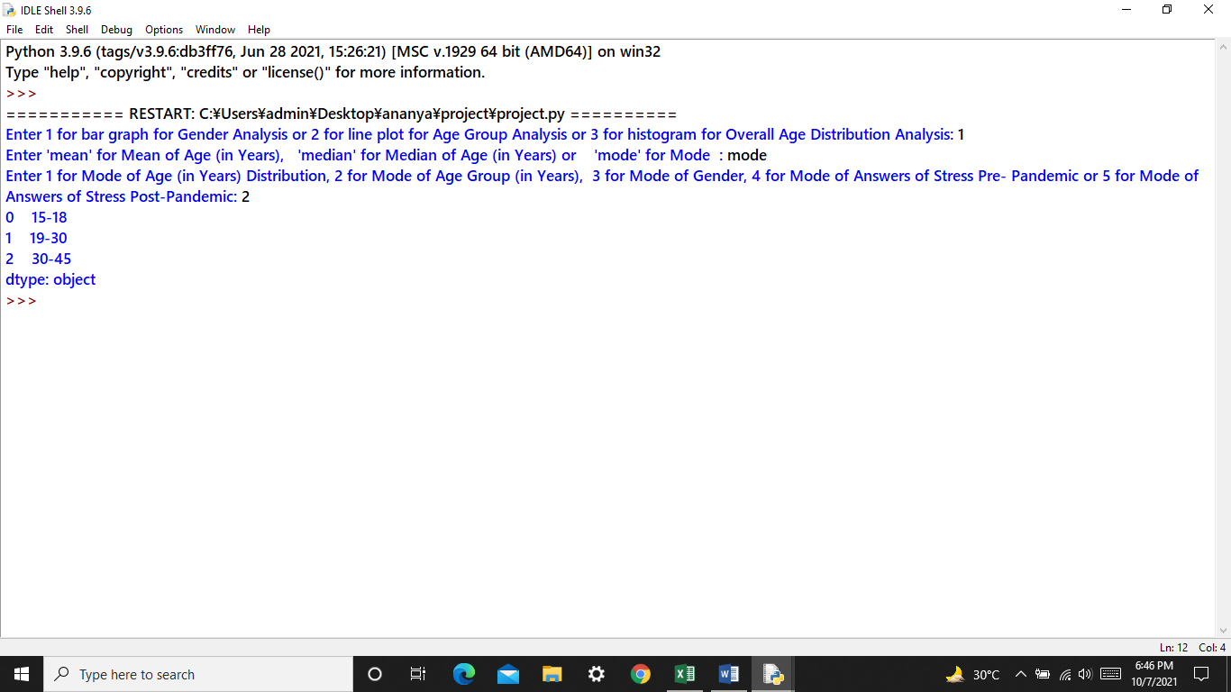
   3. **Gender**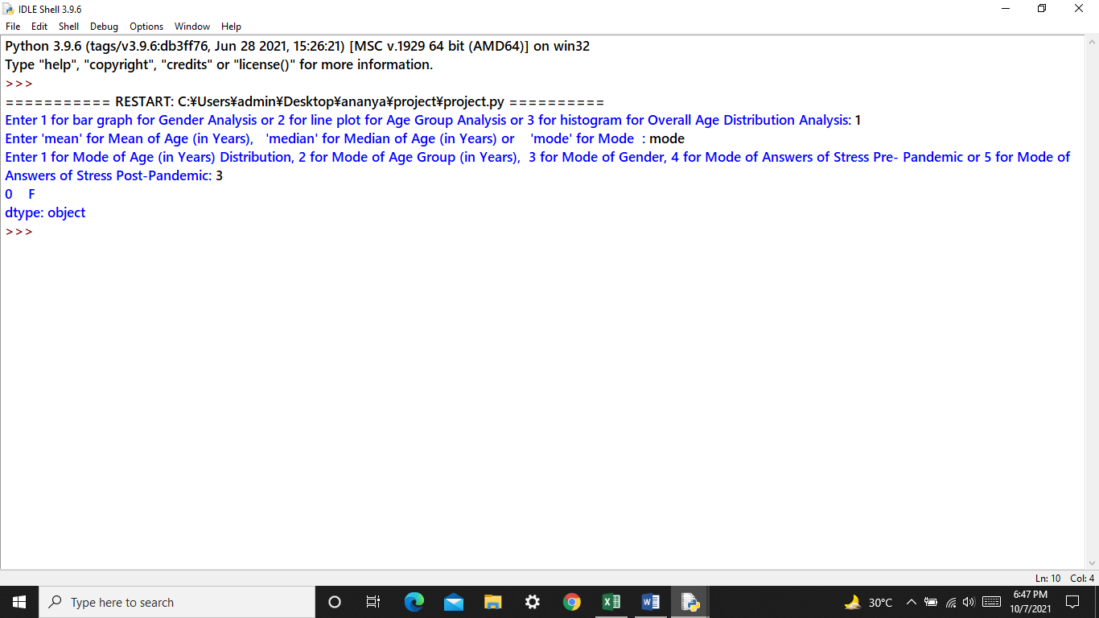
   4. **Answers of Stress Pre- Pandemic**

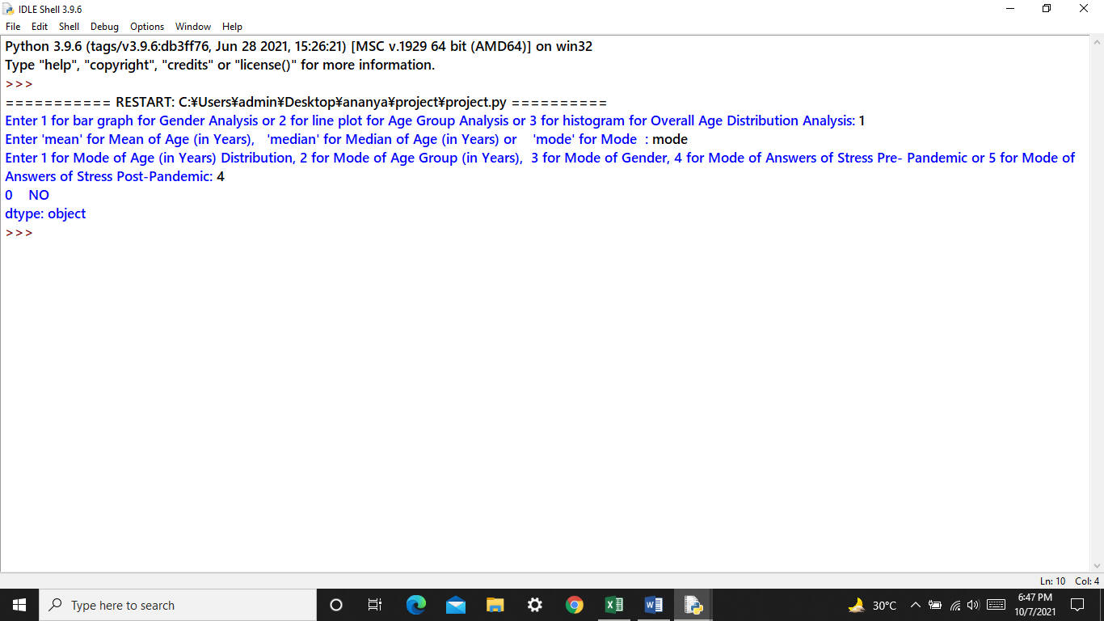

* 1. **Answers of Stress Post-Pandemic**

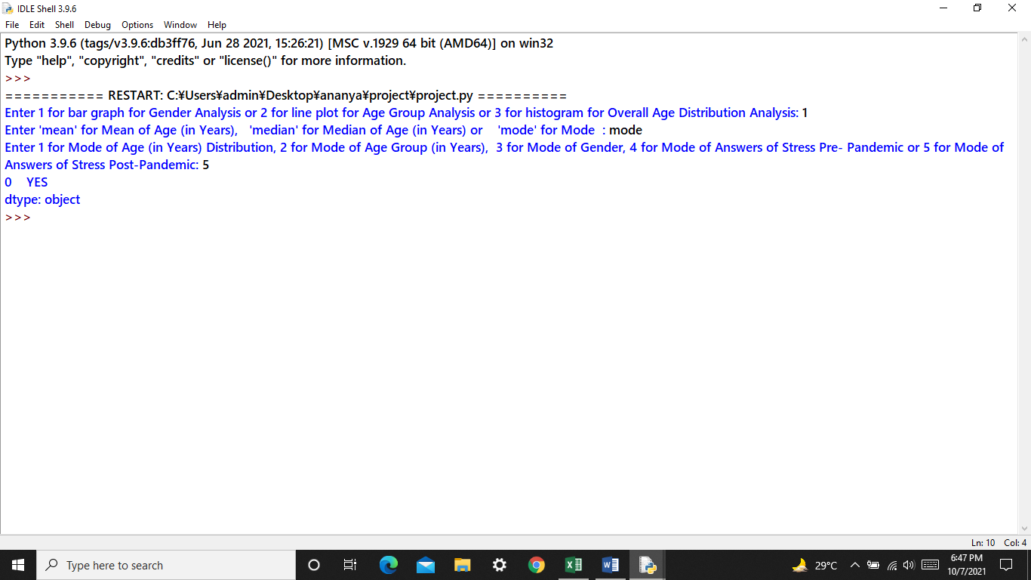

BIBLIOGRAPHY

* NCERT- Informatics Practices, Class XII
* [www.wikipedia.com](http://www.wikipedia.com)
* <https://www.google.com/imghp?hl=en>
* <https://www.geeksforgeeks.org/>

